Title
Hourly Energy Consumption Forecasting using Time Series Analysis (Prophet Model)

Objective
The objective of this project is to analyze historical hourly energy consumption data and build a forecasting model to predict future energy demand. This helps in better planning of electricity supply and demand management.
Dataset Overview
The dataset contains hourly energy consumption data with the following columns:
- Datetime (timestamp)
- PJME_MW (energy consumption in megawatts)
The data represents electricity usage patterns over time.

Data Preprocessing
The following preprocessing steps were performed:
- Converted Datetime column into datetime format
- Sorted data by time
- Set Datetime as index
- Resampled hourly data into daily data using aggregation
- Handled time-series structure for forecasting

Exploratory Data Analysis
Two main visualizations were created:

1. Energy Consumption Trend
- Shows how energy demand changes over time
- Indicates seasonal patterns and fluctuations

2. Forecast Plot
- Displays predicted future energy consumption
- Includes confidence intervals (upper and lower bounds)
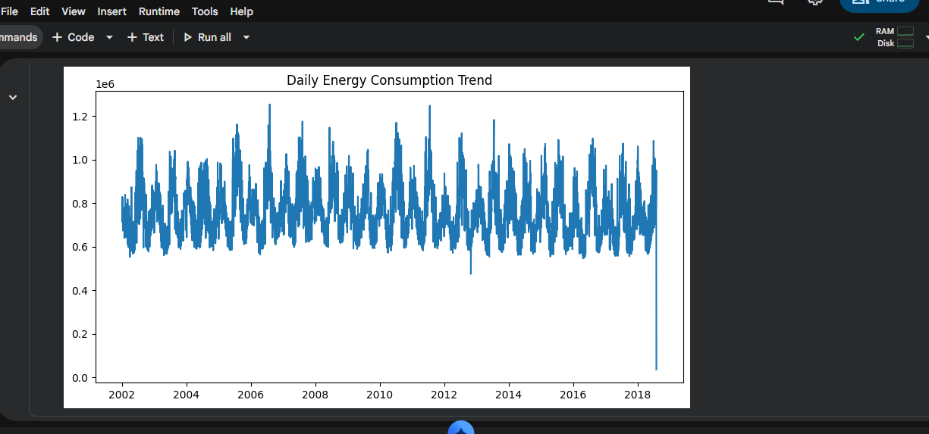

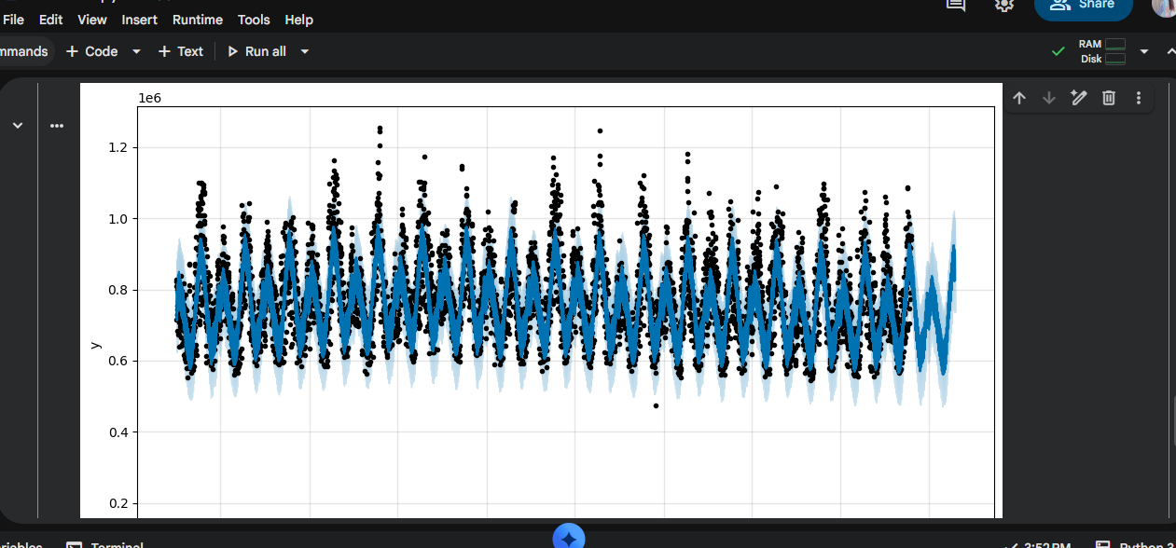

Forecasting Model Used

Prophet Model (Facebook Prophet)
The Prophet model was used for forecasting because:
- It handles time-series data efficiently
- It captures seasonality and trends
- It provides confidence intervals

Forecast Results
The model was trained on historical data and used to predict future energy demand for the next 365 days.

Key Observations:
- Energy demand shows strong seasonal patterns
- Winter months have higher electricity consumption
- Forecast indicates a stable upward trend in demand
- Peak usage periods are clearly visible
Model Evaluation
The model was evaluated using Mean Absolute Error (MAE):
- MAE value: (add your output here from code)
This indicates the average error between actual and predicted values.

💡 Business Insights
- Energy demand is increasing over time
- Peak demand periods require better planning
- Infrastructure must be improved to handle future load
- Renewable energy sources can help manage peak demand

Recommendations

⚡ Energy Providers:
- Increase electricity supply during peak seasons
- Improve grid stability and load balancing

💰 Cost Optimization:
- Introduce off-peak pricing strategies
- Encourage energy usage during low-demand hours

📊 Future Planning:
- Invest in smart grid technology
- Expand production capacity based on forecast trends

📌 Conclusion
The forecasting model successfully predicts future energy consumption trends using historical data. The insights generated can help in better decision-making for energy distribution and infrastructure planning.

